NR 465
EXAM 2 REVIEW OF CONCEPTS
- Explain the presentation of hypoglycemia of the newborn
  - Jittery, temperature instability, lethargic, poor feeder
  - Clinical therapy
    - Monitor newborn glucose during first 12 hours after birth (per agency protocol)
    - Serum glucose that falls below 40 mg/dL
    - Early feedings
    - If nursing, can try syringe feeds, SNS
    - IV glucose infusion (if no improvement with feedings)
    - D10W, 6–8 mg/kg/min
    - Skin-to-skin to raise temperature!
- Clinical presentation and differentiation of placenta previa and abruption placentae
  - Placenta Previa – placenta is implanted in lower uterine segment near or over internal cervical os. NO VAGINAL EXAMS
  - Presentation – painless vaginal bleeding, Vaginal bleeding occurs during the 2nd and 3rd trimester; First sentinel bleed is around 34 weeks; Bleeding may be intermittent or continuous; A transvaginal sonogram provides better info regarding the placement of the placenta in relation to the cervical os.
    - Marginal previa
      - Placenta is within 2-3cm of internal os but does not cover it
    - Partial previa
      - Placenta implanted near the cervix with a portion covering part of the cervical os
    - Low-lying previa
      - Placenta implanted in lower uterine segment, but does not reach os.
    - Total Previa
      - The cervical os is completely covered
    - Vasa Previa
      - Fetal vessels course through the amniotic membranes and are presenting at cervical os
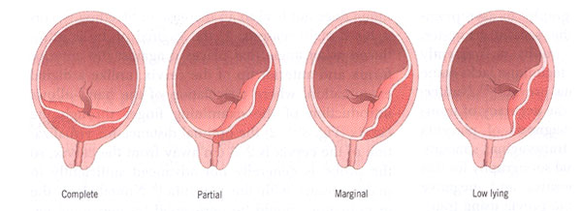
  - Abruption Placentae – Premature separation of the placenta (part or all) from its implantation site in the uterine wall
    - Cocaine use is the number 1 cause
    - Presentation – hard uterus, Sudden onset, intense often localized uterine pain or tenderness with or without vaginal bleeding
    - Contractions with or without vaginal bleeding
    - If it is a mild abruption, it may be difficult to distinguish from pain of labor contractions
    - Pain is often localized to the area of abruption
    - If placental implantation is posterior, lower back pain may be more prominent than uterine tenderness
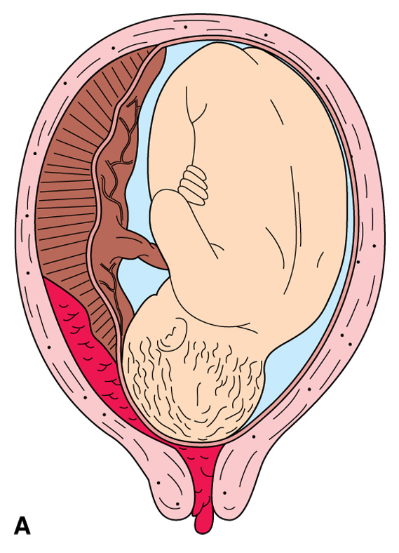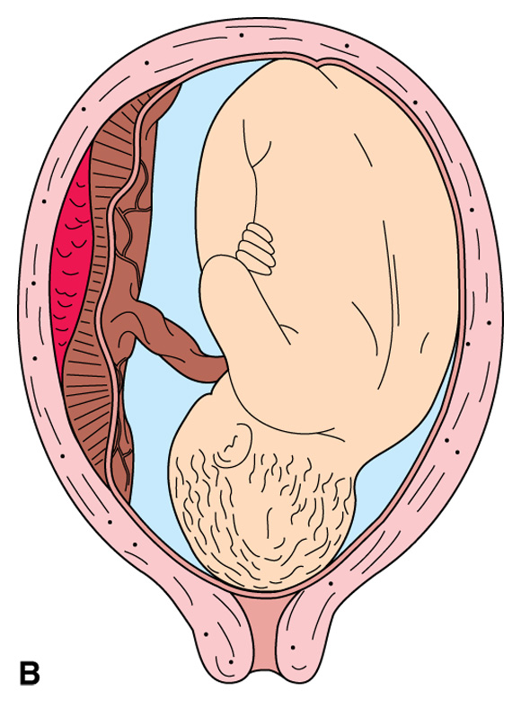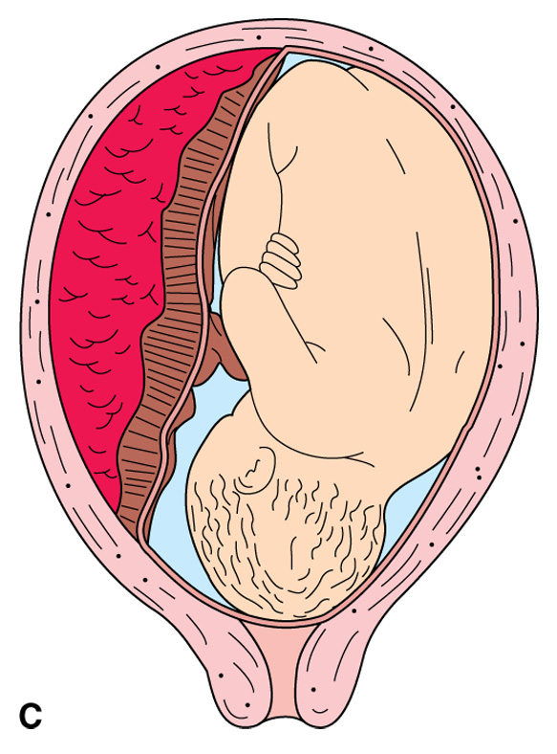

Marginal abruption Central abruption Complete abruption
- Describe mechanisms of heat loss in the neonate
  - Convection is the loss of heat from the warm body surface to the cooler air currents. Air-conditioned rooms, air currents with a temperature below the infant's skin temperature, oxygen by mask, and removal of the infant from an incubator for procedures increase convective heat loss of the newborn.
  - Radiation losses occur when body heat rises to cooler surfaces and objects not in direct contact with the body. The walls of a room or of an incubator are potential causes of heat loss by radiation, even if the ambient temperature of the incubator is within the neutral thermal range for the infant. Placing cold objects (such as ice for blood gases) onto the incubator or near the infant in the radiant warmer will increase radiant heat losses.
  - Evaporation is the loss of heat incurred when water is converted to a vapor. The newborn is particularly prone to heat loss by evaporation immediately after birth, when the baby is wet with amniotic fluid, and during baths; thus drying the newborn is critical.
  - Conduction is the loss of heat to a cooler surface by direct skin contact. Chilled hands, cool scales, cold examination tables, and cold stethoscopes can cause heat loss by conduction. Even if objects are warmed to the incubator temperature, there still may be a significant temperature difference between the infant's core temperature and the ambient temperature. This results in heat transfer.
- How do we assess adequate intake of the newborn?
  - Breastfeeding – successful latch-on and feeding should occur every 1.5 to 3 hours daily
  - Formula feeding – every 3-4 hours for full-term babies with gradual amount increases
  - We know baby is getting enough when they’re having 6-10 wet diapers a day
- Outline clinical signs of respiratory distress (RDS) in the newborn
  - Tachypnea
  - Nasal flaring
  - Chest retractions
  - Grunting
- Precipitous birth – risks
  - Fetal risks – hypoxia/ NR FHR (non-reassuring Fetal heart rate)
    - Meconium stained fluid/aspiration
    - Low Apgar scores
    - Intracranial trauma from rapid decent
  - Maternal risks – loss of coping abilities/anxiety/fear
    - Lacerations of cervix/vagina/perineum
    - PPH
- What is the “Turtle sign”, what interventions are appropriate?
  - Turtle sign – Dystocia – apply fundal pressure to role baby’s shoulder under pubis bone & put mom in MIC Roberts position HOB flat & legs up
- Why is the lecithin/sphingomyelin ( L/S) ratio test performed?
  - Surfactant is composed of lecithin & sphingomyelin (L/S) which is critical for alveolar expansion and stability L/S ration > 2:1 – suggests fetal lung maturity
- What medications are indicated for PPH, any contraindications?
  - Oxytocin – Pitocin – contraindications: IM or IV want to listen to lungs, it can cause increase in fluid (water retention)
  - Methylerogon – IM or PO give to promote uterine contraction; contraindications: Hypertension
  - Carboprost – Hemabate: 8 doses every 15 min; contraindications: asthma & can get diarrhea need an antidiarrheal
  - Misoprostil – Cytotec – off label PO or rectally and will cause and increase in temperature; contraindications: patients with fevers
- Amniotic Fluid Embolism – describe risks associated with
  - Precipitous labor
  - Smoking
  - AMA
  - C-section or instrumental delivery
  - Placenta previa or abruption
  - Grand multiparity (.5 births)
  - Cervical lacerations
  - Fetal distress
  - Eclampsia
  - Medical indication of labor
  - FATAL – immediate response is resuscitation to complete sudden cardio and pulmonary insufficiency
- What are the risks associated with cervical lacerations
  - Fluid can enter maternal circulatory system at any time there is an opening in the amniotic sax or maternal uterine veins
- Differentiate pathologic from physiologic jaundice
  - Pathologic jaundice – develops < 24 hours
    - Seen with RH & ABO incompatibility
    - Bilirubin levels increase rapidly & dramatically
    - Close surveillance warranted
  - Physiologic jaundice – develops > 24 hours
    - most common type
    - often associated with birth trauma, prematurity
- What management would the nurse anticipate when caring for an infant with hyperbilirubinemia
  - Phototherapy – use glasses to protect eyes; expose as much skin as possible; no lotions or oils
  - Kernicturus – levels >25mg/dL; may require partial exchange transfusion; often associated with cases of pathologic jaundice; leads to neurologic damage (bilirubin crosses BBB & stains brain – bilirubin toxicity)
- Identify differentiating factors between cephalohematoma and caput succedaneum
  - Cephalohematoma – collection of blood; does not cross the suture lines/collection of blood between the parietal bone and periosteal
    - Highest risk of hyperbilirubemia
  - Caput succedaneum – feels spongy and crosses suture lines
- Describe risks ( both maternal and fetal) associated with post-term pregnancy
  - Fetal surveillance – 2 times a week
    - Non-stress test – reactive twice in 20 minutes
- When are forceps used? When are they contraindicated?
  - Forceps are used – to help rotate the fetal head to an occiput-anterior position from an occiput-posterior position; are used to shorten the second stage of labor: fetal compromise; maternal exhaustion; maternal complications such as bleeding; unable to push due to epidural
    - Fetal head must be engaged
    - Amniotic membranes must be ruptured
    - Fetal head to pelvic disproportion is not present
    - Cervix is fully dilated to 10cm
    - Adequate pain control has been provided
    - Informed consent was received
  - Complications – Fetal: ecchymosis; edema; caput succedaneum; cephalohematoma; low Apgar scores; retinal hemorrhage; elevated bilirubin level
    - Maternal – lacerations to the perineum, vagina, bladder, & cervix; injury to the anal sphincter; hematoma; PPH; pelvic prolapse
- Describe nursing interventions during an amniotomy.
  - Artificial rupture of membranes (AROM) – typically used to augment or shorten labory
    - Assess fetal heart rate before and after
    - Maternal temp q4h
    - Document – time, color, odor, amount
      - Meconium stained fluid? Think or thin or particulate – prep for NNP, neonatologist at delivery
- Clinical presentation of shoulder dystocia. Causes?
  - Following birth of the head, the anterior shoulder of the baby does not emerge spontaneously or with gentle traction (turtling of the head – retracts against perineum and external rotation does not occur)
    - Large baby
- Nursing interventions associated with a prolapsed cord.
  - Put pressure on the presenting part to take pressure off the cord
